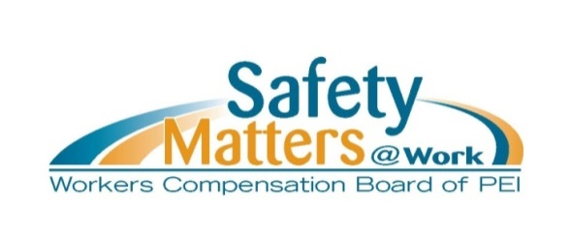
Health and Safety Orientation for Workers
Checklist – July 2025

This checklist is your guide for conducting a health and safety orientation for workers. It is important and necessary that you customize this document to meet the unique circumstances of your workplace or work site. A thorough orientation should cover any unique hazards, specialized equipment, or site-specific procedures for workers.

Checking off each item confirms that the topics have been reviewed with the worker.
COMPANY SAFETY REQUIREMENTS |  | N/A | Notes
Safety policy – If applicable, review the company’s safety policy to make sure the worker understands the organization’s commitment to maintaining a safe workplace.
Roles and responsibilities – The worker understands the responsibilities of the employer, supervisor, and worker in maintaining a safe work environment.
Workplace harassment – The worker has reviewed the company’s workplace harassment policy and understands how to recognize, report, and prevent harassment.
Safe work procedures and policies – The worker has been trained on established safe work procedures and policies relevant to their role.
Incident reporting – The worker understands the process for reporting unsafe work conditions, near misses and workplace incidents.
WHMIS – The worker has received training on Workplace Hazardous Materials Information System (WHMIS) and understands how to safely handle hazardous substances.
Safety committee and Safety Representative – If applicable, the worker has been introduced to the company’s Safety Representative or Safety Committee members and understands their role in making sure the workplace is safe.
Ergonomics and hazard recognition – The worker has received training in proper ergonomics, injury prevention, and identifying workplace hazards.
Workplace inspections and safety controls - The worker is trained on the workplace inspection process and on how to correct hazards
Right to refuse unsafe work – The worker understands their right to refuse unsafe work and the steps to follow if they believe a task is unsafe.

PERSONAL PROTECTIVE EQUIPMENT (PPE) |  | N/A | Notes
PPE requirements – The worker is aware of the required PPE for their role including when and how to use it.
Use, fit, storage, maintenance – The worker has been trained on the correct use, fit, storage, and maintenance of required PPE.

IMPORTANT CONTACT INFORMATION |  | N/A | Notes
Supervisor – The worker knows who their direct supervisor is and how to contact them for safety concerns.
Safety Representative – If applicable, the worker is aware of who the Safety Representative is and how to contact them for safety-related issues.
Safety Committee Members – If applicable, the worker has been provided with the names and contact information of Safety Committee members and knows to contact them for safety-related issues.
Workplace First Aiders – The worker knows who the Workplace First Aider(s) are and how to contact them when first aid is necessary.

EMERGENCY PREPAREDNESS |  | N/A | Notes
Emergency Procedures – The worker has been trained on emergency response procedures, including evacuation and other procedures for different emergency situations in the workplace.
First Aid Kits - The worker is aware of the contents and location of the first aid kit.
Workplace First Aiders – The worker has been introduced to the Workplace First Aider(s) and how to contact them when first aid is necessary.

OTHER - INCLUDE THE UNIQUE SAFETY FEATURES OF YOUR WORKPLACE

Include the signatures from all parties to indicate that the orientation has been completed to the satisfaction of the employer, supervisor and worker.

A copy of this checklist should be retained in the worker’s personnel file.

_______________________ ________________________ _____________
Worker Name Worker Signature Date

_______________________ ________________________ _____________
Employer/Supervisor Name Employer/Supervisor Signature Date

